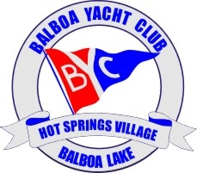
2/20/2018

Balboa Yacht Club Board Meeting
Jeff Lloyd Commodore- opened the meeting, Jeff notified the board that he had possession of the Hydrilla sign and Jeff made a motion that a second signature be added to the club bank account and a second card be secured. Stacey Lloyd seconded the motion and DC Reed agreed to be the second signer.
Stacey Lloyd- reported to the group the results of the Day at the Races. We had a net loss of $74.33. This was a result of being charged for 1 additional person then what attended and the fees for PayPal. Stacey related that it was a learning experience especially with the PayPal charges which are about 3% per transaction. DDDC asked if we did this event again do we have the ability to order from menu. Stacey did not know and told him she would follow up.
Stacey also discussed the upcoming Cocktail Hour at Balboa Lounge on March 22nd. The board unanimously voted to call our Cocktail hour group the “Down the Hatch Crew”.
The board also unanimously voted to price the Fish Fry Plus at $17.50 per person to cover the cost of PayPal, Pavilion Rental and other supplies.
The Board also decided that we need to hold a Membership Meeting at the August Event to discuss the Lake Drawdown and actions that need to be taken. The Board also unanimously decided that the event needs to be held in the first 2 weeks of August.
DC Reed- brought before the Board his findings with his CPA regarding the Clubs need to file 990-N with this IRS to avoid losing our Tax Exempt Status. We only have 3 years, which ends this year, to file the return and retain our status. It is a simple postcard filing. We need to secure the EIN # for the Club to file this card. DC made a motion and Jeff Lloyd seconded it to have this form filed before the deadline of July 15, 2018.
Jeff Lloyd made a motion to secure a mailbox for the Club to avoid mail going to individuals homes, and having past members or Commodores receiving mail. DC Reed seconded the motion to secure a mailbox for the Club.
The Board discussed the need to complete the membership packages and have them for all members. Stacey motioned to allow funds to be available for DC to purchase the supplies for the member packages and Jim seconded the motion. The packages will include: name tags, laminated map and lake rules.
Board discussed the classes to be held at the Marina. The first class would be the knot tying class. DC motioned for funds for Jeff Lloyd to purchase to make the knot tying board, it was seconded by Jim.
Stacey motioned that the Name Tags be updated. She recommended that they say: Commodore, Board, Events Committee, Past Commodore, it was seconded by DC who agreed to print the new name badges.
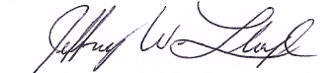
Discussed next meeting, Jim will be gone from April 21- May 9.

